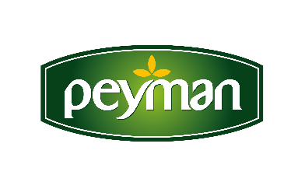
PRESS RELEASE October 2021

" The Brand that Best Manages Customer Experience Award" to Peyman

Peyman, the innovative brand of the nuts industry, was selected the first in the dried fruit category at the A.L.F.A. Awards where “Brands that Best Manage Customer Experience” are determineed. Peyman, the owner of the “Customer Brand” award, was deemed worthy of this award with the bond it established with its consumer, customer satisfaction and sustainable customer relations.

Turkey's liked dried fruit brand Peyman is not satisfied with awards not only for its flavors but also for its marketing achievements. Peyman won the “Customer Brand” award as the winner of the dried fruit sector in the A.L.F.A. Awards research, in which "Brands that Best Manage Customer Experience" were awarded. The winners of the A.L.F.A. Awards were announced at the ceremony held at Hilton Istanbul Bomonti following the Experience Design and Management Summit XCO'21 on October 6th.

“This valuable award is an indication of the strong and deep bond we have established with our customers”

Ali Burak Aygül, Peyman Marketing Director; spoke: “The A.L.F.A. Awards is extremely meaningful to us. We see this award as a good return of our continuous growth-oriented investments and the value we place on our customers. With the investments we make, we introduce Peyman flavors to more and more consumers, both at home and abroad. Recently, we achieved to reach our British consumers faster by taking part in the UK channel of the world's largest e-commerce site Amazon with our own brands. Our e-commerce site, www.peymanshop.com , which started its operations recently, was a big step towards strengthening our bond and sustainable relationship with our customers. We will continue to work with energy and bring Peyman's gourmet delicacies to more consumers.”

The A.L.F.A. Awards have been held since 2015
The A.L.F.A. Awards research, in which “Brands that Best Manage Customer Experience” are awarded, has been organized in collaboration with Marketing Turkey and AKADEMETRE since 2015. At the A.L.F.A. Awards, where the brands creating the best customer experience are awarded, brands that stand out with their success in customer experience management and establish a healthy and sustainable relationship with their customers are selected.

For more information and communication;

ESRA ERDOĞAN
Senior Trademark Manager
