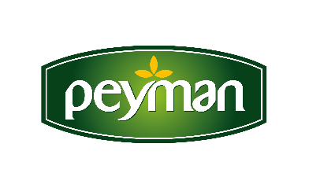
PRESS RELEASE September 2021

Peyman tastes are on Amazon UK!

Peyman, pioneering the Turkish dried nuts market with its innovative and gourmet products, has taken its growth journey in global markets to a different level. Peyman, exporting to nearly 50 countries, managed to enter the UK channel of Amazon, the world's largest e-commerce site, with its brands of Bahçeden, Nutzz and Çitliyo. Peyman's gluten-free products were included in the “healthy snacks” category of the site.

Turkey's popular dried nut brand Peyman has added a new one to its success in the global market. Peyman, which is in the "Healthy Snacks" group of Amazon UK with Bahçeden, Nutzz and Çitliyo brands, achieved another success in this challenging market by gaining the appreciation of British consumers who are very sensitive about nutrition.
“We exist with our own brands”
Peyman CEO Kaan Baral said that they will continue to be a pioneer in the sector as Peyman and emphasized that their presence in Amazon UK is an important development for the Turkish dried nuts sector. Baral said: “Turkey is the second largest player in the dried fruit industry in the world. We are the world's largest producer and exporter of hazelnuts, apricots, figs and grapes. As Peyman, we deliver Turkish nuts to more than 50 countries in a wide geography from America to Australia, from Europe to the Middle East. Increasing the number of markets we exist in abroad with our own brands is among our most important goals. In this respect, being on the list of Amazon UK with our 3 brands is an important success for both Peyman and the Turkish nuts sector. The British consumer, who is sensitive about healthy nutrition and snacks, closely follows the ingredients of the products they eat. We observe a strong interest in our gluten-free and gourmet products in Amazon UK. We will continue to strengthen our presence in foreign markets with our innovative tastes and quality.”

www.peyman.com.tr

