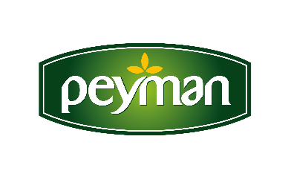
PRESS RELEASE April 2022
The most special flavour of Ramadan month Peyman Bahçeden Dates comes to the meals

Dates, which are the indispensable flavour of Ramadan, become indispensable for the meals with its special flavour leaving a mark on palates. With Peyman Bahçeden Dates, the biggest flavour accompaniment of these special moments, you can eat healthy and balanced in iftar and sahur with it which is rich in potassium and high fiber.

When it comes to Ramadan; abundance, plenitude, spirituality and Ramadan tables equipped with delicious dishes come to mind. In Ramadan, where the number of meals has decreased to two, healthy and balanced nutrition is more important than ever. Bringing the best dates to the meals in zippered special packages, Peyman Bahçeden dates become indispensable for Ramadan meals with fresh date flavour and accompany iftar menus.

Both healthy and delicious Peyman Bahçeden Dates
Peyman Bahçeden Dates, the honour guest of the tables in Ramadan, is a great alternative for those who do not compromise on taste and healthy nutrition. This unique taste meets the needs of the body with many vitamins and minerals as well as the high fiber and potassium it contains. When fasting at iftar or consumed at sahur, Peyman Bahçeden Dates, which does not lose its freshness with its airtight and hygienic packaging, prevents digestive problems, reduces inflammation and helps reduce the risk of many chronic diseases.

Apart from Ramadan; as a useful source of fiber as a snack, Peyman Bahçeden Dates is collected from the most fertile soils in the healthiest methods and accompanies the meals.

www.peyman.com.tr

For more information and communication

