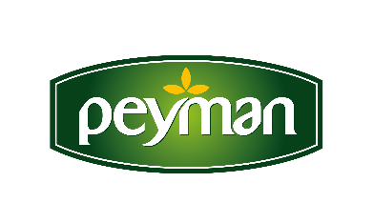
PRESS RELEASE October 2021

Peyman's e-commerce website was opened…

Peyman, the leading brand of the Turkish dried nut market, started to bring together its innovative and gourmet products to the consumers through its new sales channel. In the www.peymanshop.com store opened as of October; It is possible to reach Bahçeden, Nutzz and Çitliyo brands with just one click.

Turkey's liked dried nuts brand Peyman has added a new one to its digital investments that do not slow down. Peyman's e-commerce site www.peymanshop.com started its operations with a wide range of products.

Stating that they continue to grow and become stronger as the pioneer and innovative brand of the nuts industry, Peyman CEO Kaan Baral said, “As a brand that keeps up with the times and lives in technology and innovation in all its processes, we continue to work with energy to expand both our production and sales power as always we do.”

“Gourmet tastes in our online store”

Stating that they will continue their investments as Peyman, Kaan Baral continued his words as follows: "We have recently succeeded in being featured on the UK channel of the world's largest e-commerce site Amazon with our own brands and we have started to deliver our gourmet tastes to British nuts lovers. We continue to add new ones to this success without slowing down. Our e-commerce site www.peymanshop.com that has started operations is an important and big step to reach our goals. With our new sales channel, we will be able to reach anyone who loves Peyman's innovative nuts, wherever they are, whenever they want. We will bring together the power of the Peyman brand in the field with our consumers, regardless of location and time limit.”

www.peymanshop.com

For more information and communication;

ESRA ERDOĞAN
Senior Trademark Manager
