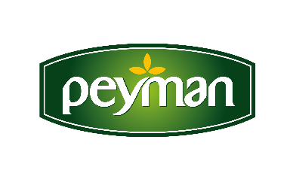

PRESS RELEASE November 2020

The joy of dried nuts is now gluten-free with Peyman!

Peyman, which started its gluten-free production movement with the Çitliyo sunflower seed family, made dried nuts accessible to those with gluten sensitivity and celiac disease by eliminating the risk of gluten contamination during the production process. For everyone to notice easily, the inscription “gluten-free” has also taken its place in the specially designed packages of the New Bahçeden product family. Those who are sensitive to gluten and prefer a gluten-free diet will be able to enjoy the new Peyman Bahçeden family's raw, roasted dried nuts and dried fruit products with peace of mind.
People with celiac disease and gluten intolerance need to eat gluten-free. Those who take care of their nourishment can also choose a gluten-free diet. Peyman, one of the leading brands of dried fruits and nuts industry that enters almost every household and consumed enjoyably, now offers its new “Bahçeden” family gluten-free by adding innovation to dried nuts. In the new generation packages of the “Bahçeden” family, there is visible information about the high fiber content, health benefits, and being gluten-free.

Registered with 'Gluten Free' certificate

Dried nuts do not contain gluten. However, since there is a risk of gluten contamination during the production phase, separate machines and technologies must be used for gluten-free production. Peyman, who started gluten-free production with the great investment it made in his factory in Eskişehir, guides the way with the "Gluten-Free" certificate it received and registered his production with.

Peyman aims to contribute to the increase of health literacy with Bahçeden Family's new generation packaging. The packaging of the Bahçeden family, which brings together Peyman's raw, roasted nuts and dried fruit products, contains important information about its health benefits as well as being gluten-free.

www.peyman.com.tr

