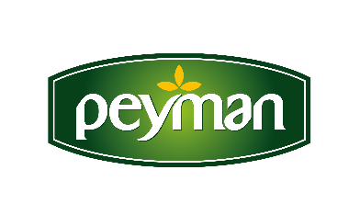
PRESS RELEASE June 2021

Turkey didn’t give up its traditional taste dried nuts during pandemic
It consumed 514 thousand tons of dried nuts in 2020
The process of staying at home during the 2020 pandemic period led the Turkish people to consume dried fruits and nuts. Spending long hours indoors significantly increased snacking. Noting that approximately 98 percent of the households in Turkey bought dried nuts, Peyman CEO Kaan Baral said, "Due to the increase in the demand for dried nuts during the pandemic period, the packaged dried nuts market’s turnover rate grew by 45 percent."
During the pandemic period, the trend towards healthy eating and the demand for reliable and hygienic products increased the interest in packaged products in dried nuts. While the open and packaged dried nuts market reached 31 percent growth rate in turnover in 2020, the packaged nuts category grew by 45 percent, surpassing the total market growth. The total dried nuts market reached 18 billion TL and the packaged dried nuts market reached approximately 5.5 billion TL.
“We are the pioneer of the new snack trend”
Kaan Baral, CEO of Peyman, who noted that the number of households in which Peyman products entered increased by 19 percent in 2020 with the effect of the pandemic, stated that an average of 25 kilograms of dried nuts are bought to a household during the year. Stating that there is a sensitivity towards gluten-free products in the world and in Turkey, Baral said: “Especially in recent years, there has been an intense trend towards healthy nutrition and healthy snacks all over the world. As Peyman, we act with the mission of delivering our dried nuts to our consumers by producing them in the healthiest and most hygienic systems. We became the pioneer of the new snack trend in the industry, and despite the pandemic, we accelerated our investments and turned our factory into a gluten-free production area. We were also proud to receive the first Gluten Free and TSE Covid-19 Safe Production certificates in our industry.”
“Turkey is the world's most popular dried nuts and fruits producer”
Peyman CEO Kaan Baral, who underlined the need for more work for the Turkish dried nuts industry to achieve greater success in the world markets, said: “Today, Turkey is one of the world's leading producers and exporters of dried fruits and nuts. We must focus on investments to present these special products grown in the rich lands of our Anatolia to the world, not only as raw materials, but also with the vision of strong brands. The increase in agricultural support and the strengthening of state-producer-industrialist cooperation are the most important factors in achieving our global market targets. As Peyman, with the awareness of our duty at this point, we focused on production and innovation at international standards. We deliver Turkish dried nuts to the world with our healthy, gourmet and innovative products under our brands Bahçeden, Çitliyo and Nutzz.”

“Our priority in 2021 is; digital transformation, innovation and export”
Stating that Peyman exported to more than 10 new countries during the pandemic and achieved a growth of approximately 70 percent in exports in 2020, Peyman CEO Kaan Baral said: “Within the framework of our strategies for 2021 and beyond, our targets in digital transformation, innovation and export are in the top three in the ranking. We will continue to make investments that will strengthen our technological infrastructure by increasing the size of the transition to digital systems that we started in 2020. In our business areas, we aim for fast, powerful and widespread communication through more effective usage of automation and robotic processes.”
www.peyman.com.tr

For detailed information;
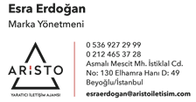 (Brand Manager)

