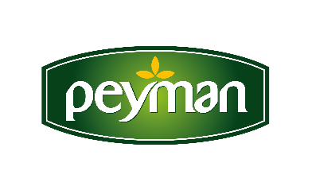
PRESS RELEASE July 2021

Peyman as the “Nuts Brand of the Year”!
Peyman, the leading brand of the nuts industry, won the "Nuts Brand of the Year" award at the Turkey's Leading Brand Awards 2021.

Expanding its gourmet and innovative product range day by day, Peyman has successfully represented the Turkish nuts sector in the country and abroad, and crowned its success with a new award. It was selected as the "Nuts Brand of the Year" at the Turkey’s Leader Brand Awards, which was held for the second time this year within the scope of Turkey’s brand and career events.
The award ceremony, which brings the world of business and art together, was held on Tuesday, July 13, with a great organization at the Hilton Istanbul Bomonti Hotel.
“This Award Symbolizes Our Achievements”
Peyman CEO Kaan Baral received the award on behalf of Peyman at the ceremony. Baral expressed his happiness about the award with the following words: ‘‘As Peyman, we are honored to receive the Nuts Brand of the Year Award. We are proud of being a company that introduced the nuts industry to innovation. We deliver the most gourmet varieties of nuts and dried fruit to our consumers with our brands Bahçeden, Çitliyo and Nutzz. We are constantly working to produce the best and the highest quality and we continue our investments. Today, Turkey is one of the world's leading countries in the production of nuts and dried fruit. We are happy to introduce this value of our country to 50 countries in the world as a global Turkish brand.”

www.peyman.com.tr

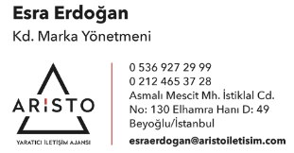
For more information and to be in contact:

